ELECTION DATA ANALYTICS DASHBOARD
Using Python, Pandas, Matplotlib and Streamlit

IBM SkillsBuild / BharatCares Data Analytics with AI Internship
Student Name: ______________________________
USN / Roll No.: ______________________________
College: _____________________________________
Submission Date: ______________________________

Project note: The bundled dataset is synthetic educational data for demonstrating the analytics workflow.

1. Abstract
This project presents a beginner-friendly election data analytics dashboard. The objective is to transform tabular election-style data into clear business-intelligence-style views: key performance indicators, group comparisons, trends, and decision-oriented follow-up areas. The implementation uses Python with Pandas for data preparation, Matplotlib for charts, Jupyter for reproducible analysis, and Streamlit for an optional interactive dashboard.
The project follows the training framework shown in the internship session: Data -> Information -> Insight -> Decision -> Action. The dashboard is intentionally descriptive and neutral. It reports patterns in the supplied dataset without predicting election outcomes or recommending political choices.

2. Problem Statement
Raw election-style records can contain many rows and multiple measures. A user needs a simple way to understand participation, vote distribution, winning margins, and differences across regions and parties. The problem is therefore to clean the data, calculate useful indicators, visualize the results, and organize the information into a small number of logical dashboard pages.

3. Objectives
- Load and inspect a structured election dataset.
- Calculate turnout and winning-margin indicators.
- Build clear KPIs for an executive overview.
- Compare vote totals across parties and regions.
- Create visualizations that support quick interpretation.
- Provide a reproducible notebook and an optional Streamlit dashboard.

4. Dataset Description
The included CSV has 144 rows representing 48 constituencies with three candidates per constituency. Values are synthetic and are included only so that the project can run immediately. Replace the CSV with the dataset provided for the internship before final submission, while keeping the required fields or updating the notebook column-mapping cell.
Column | Meaning | Type
Region | Region or state label | Text
Constituency | Constituency identifier | Text
Registered_Voters | Registered voter count | Integer
Votes_Cast | Votes recorded in constituency | Integer
Candidate | Candidate label | Text
Party | Party label | Text
Votes_Received | Votes received by candidate | Integer
Rank | Candidate rank in constituency | Integer

5. Tools and Technologies
Tool | Purpose
Python | Core programming language
Pandas | Data loading, cleaning and aggregation
Matplotlib | Static charts for the report and notebook
Streamlit | Optional interactive dashboard
Jupyter Notebook | Reproducible project analysis

6. Methodology
The analysis is organized into a simple pipeline so that every step connects to the dashboard story.
Step 1 - Load: Read the CSV into a Pandas DataFrame and inspect row count, column names and sample records.
Step 2 - Prepare: Calculate turnout percentage and identify winners using the rank field.
Step 3 - Measure: Aggregate registered voters, votes cast, party vote totals and winning margins.
Step 4 - Visualize: Create a small number of charts rather than a data dump.
Step 5 - Interpret: Use the charts to identify areas that deserve deeper investigation.
Step 6 - Present: Organize the results into three dashboard pages and document the workflow.

7. Data Preparation Logic
Turnout is calculated as Votes_Cast / Registered_Voters * 100. A candidate with Rank = 1 is treated as the winner. The winning margin is the winner vote count minus the second-ranked candidate vote count for the same constituency. At constituency level, registered voters and votes cast are counted once per constituency to avoid double-counting across candidate rows.

8. Dashboard Hierarchy
- Page 1 - Executive Overview: What is happening?
- Page 2 - Party & Region Analysis: How do results differ across groups?
- Page 3 - Turnout & Margin Analysis: Where are the notable participation and margin patterns?

9. Results - Page 1: Executive Overview
The executive page presents five top-level measures: number of constituencies, registered voters, votes cast, average turnout, and average winning margin. A party-level chart then summarizes winning votes in the current dataset.
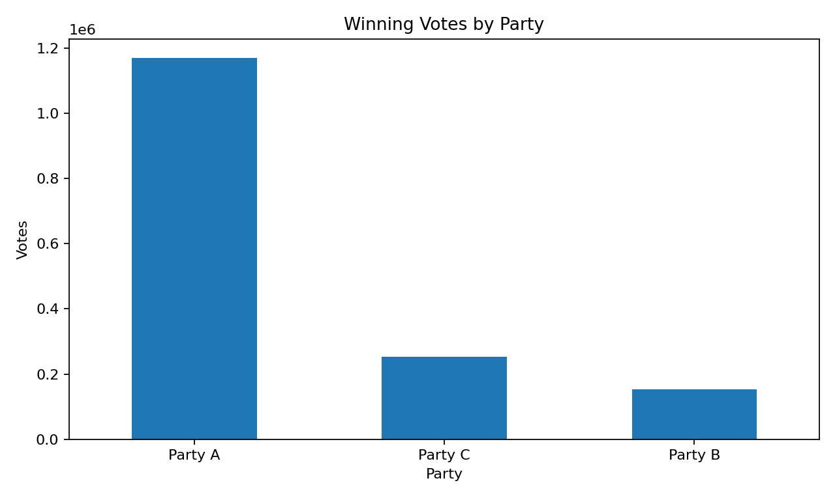
Figure 1. Winning votes by party in the bundled synthetic dataset.

10. Results - Page 2: Party & Region Analysis
The second page compares vote totals by region and party and provides a table of winning candidates. This view is designed to answer a comparison question rather than display every available column at once.
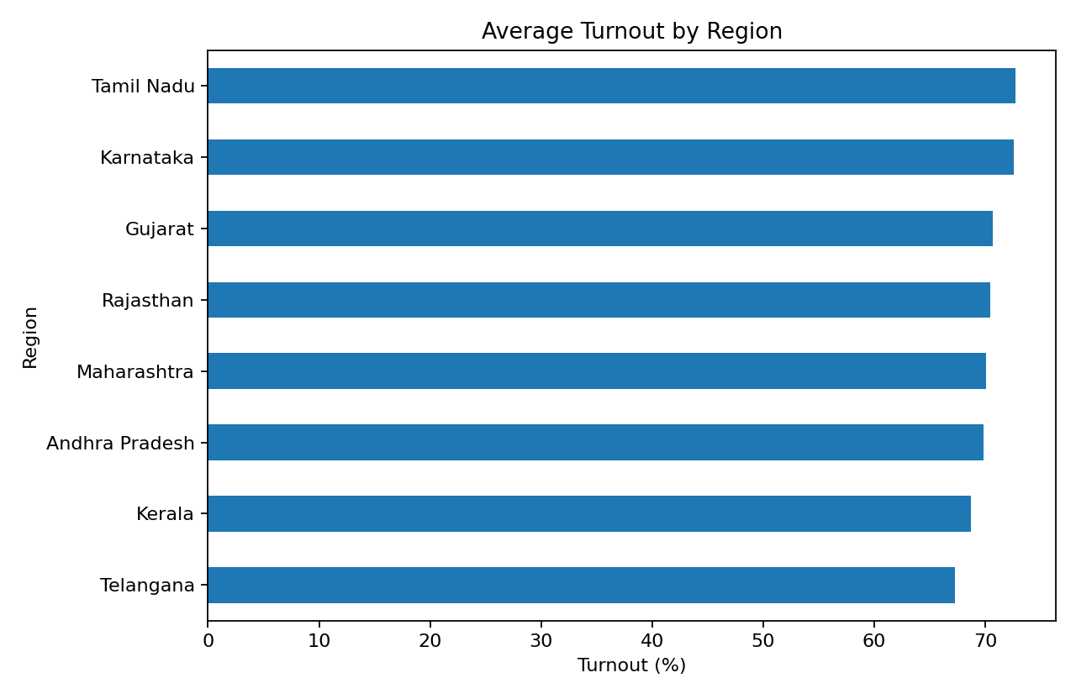
Figure 2. Turnout by region in the bundled synthetic dataset.
Region | Votes cast | Turnout %
Telangana | 1,416,027 | 67.25
Kerala | 1,548,348 | 68.69
Andhra Pradesh | 1,306,779 | 69.80
Maharashtra | 1,504,623 | 70.07
Rajasthan | 1,395,519 | 70.43
Gujarat | 1,476,501 | 70.66
Karnataka | 1,399,848 | 72.59
Tamil Nadu | 1,484,406 | 72.71

11. Results - Page 3: Turnout & Margin Analysis
The third page focuses on participation and winning margins. These are useful descriptive measures for identifying records or regions that may deserve additional investigation, data validation, or segmentation.
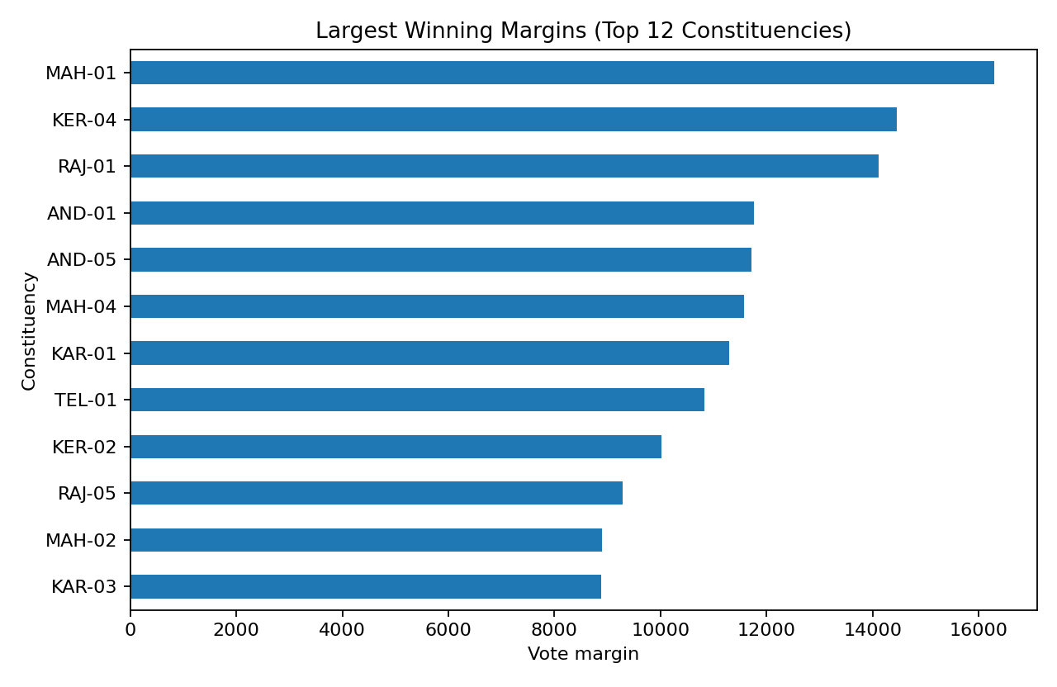
Figure 3. Largest winning margins in the bundled synthetic dataset.
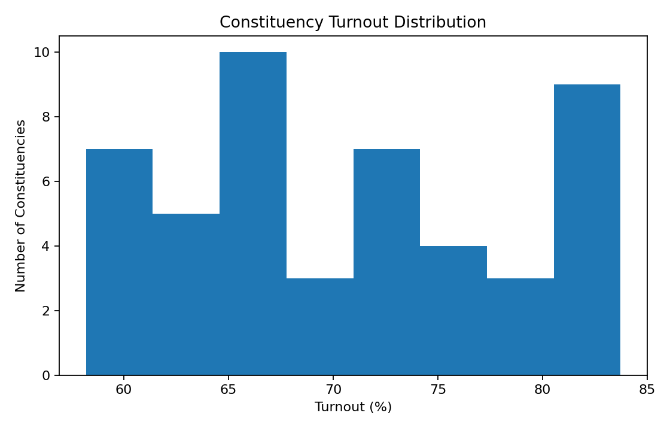
Figure 4. Distribution of constituency turnout in the bundled synthetic dataset.

12. Insights and Decision-Oriented Follow-Up
- Turnout can be compared consistently across regions when registered voters and votes cast are calculated at constituency level.
- Party totals can reveal differences in vote concentration across the selected dataset.
- Winning-margin analysis highlights constituencies with larger or smaller vote gaps between the top two candidates.
- The best follow-up questions depend on the real dataset used for submission; examples include checking missing values, duplicate records, unusual turnout values, and differences by year or demographic segment when those fields exist.
These points are analytical observations about the dataset structure and should not be interpreted as political recommendations.

13. Project Implementation
The submission package contains a Jupyter notebook, Streamlit application, requirements file, README, sample CSV, editable Word report, and PDF report. The notebook runs locally in VS Code/Jupyter. The Streamlit application can be started with the command:
streamlit run app.py

14. Google Sheet Compatibility
The Streamlit application includes a GOOGLE_SHEET_CSV_URL setting. A Google Sheet that is available as a CSV export can be connected by placing its CSV URL in that setting. The local CSV remains the fallback so that the project runs even when the online sheet is not accessible.

15. Limitations
- The bundled dataset is synthetic, not official election data.
- The analysis is descriptive and does not make causal claims or predict outcomes.
- The quality of the final results depends on the actual internship dataset and its definitions.
- If the real dataset uses different column names, the notebook and app must be mapped to those names before submission.

16. Conclusion
This project demonstrates a simple end-to-end data analytics workflow: load data, prepare measures, create KPIs, visualize patterns, and organize the results into a decision-oriented dashboard. It is intentionally small enough for a beginner to understand and explain in a viva while still following the dashboard principles presented in the internship training.

